Step 1: Choose two works, from different artists, from the LISTEN: Table of Experts media presentations that you would like to discuss/compare contrast. You will want to drag both still shots of the works to your desktop or do a Google image search of the works and save them to your desktop.
Step 2:
In an MS Word document you will want to include both images (1 MB each max). For each chosen image and under each image you should research and write about the following:

The title of the work and the artist. (Titles of artworks are capitalized and always italicized)
Describe what you see in the artworks that you can name. If you see un-namable shapes or objects (abstract objects), describe their colors, line quality, texture, shadows, variety, etc.
Which Essential Element or Principle of Art is most obvious to you in each work? (The LISTEN: If you opted for a textbook the content area for understanding the Elements and Principles of Art is there as well as online for free here.)
What are the mediums the artists use? (Painting, sculpture, installation, video, photography, ceramics etc.?)
According to the artist or expert talking, what is the meaning of the artwork?
Which element or principle of art do you see that the artist uses to help convey that interpretation?
Compare and contrast one element or principle in the 2 artworks you chose - how are they similar? How are they different?
What changed in your understanding of each artwork after your observation and analysis?
Step 3:
Save your edited word document on your desktop/hard drive.
Step 4: Highlight and select the images and the text from your Word edited document, then choose copy. This holds them in memory while you return to the course and paste into the forum post location. This is where your classmates automatically post, too, so you can see how others have approached this same LISTEN activity. If you have difficulty copying the images, you might have to upload each one separately, the paste the text you wrote. You will also upload your Word document to the discussion as well as copy and paste into the discussion. If you have difficulty posting your images, you can attach them to your post, but be sure to insert them into your final word document attached as well.

I picked

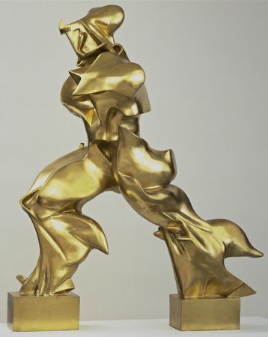

https://www.moma.org/multimedia/audio/373/6316

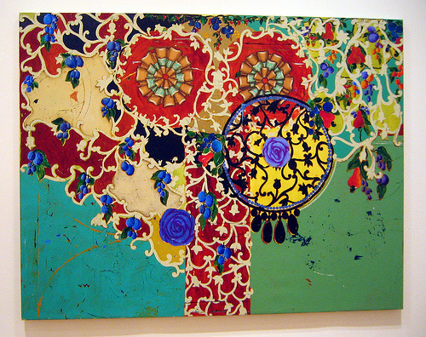
And

https://www.moma.org/multimedia/audio/49/988

